Practicum Case | 
COMP6885 | COMP6885001
Natural Language Processing
Computer Science | O251-COMP6885-JD01-11
Valid on Odd Semester Year 2024/2025 | Revision 00

Learning Outcomes
- LO2 - explain Explain fundamental concepts of how to work with Natural Language Processing
- LO3 - apply Natural Language Processing concepts in certain real-world applications
- LO4 - construct Natural Language Processing applications

Topic
- Session 11 - NER with SpaCy

Sub Topics
- NER with SpaCy

Soal
Case
Learning NER with SpaCy

You have a senior programmer that taught you how to use NER with SpaCy. Your task is to review the process by doing this step:
- First you will use this data in your code:
sentence = 'Budiman Goodboy is so genius, he can defeat everyone in Bina Nusantara at coding'

- Use Spacy to find named entities in that sentence.
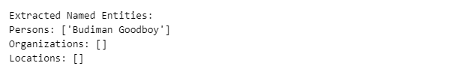
Figure 1. Named Entity Result
- Then try to find categorized named entities from ‘Paragraft.txt’ text using SpaCy.
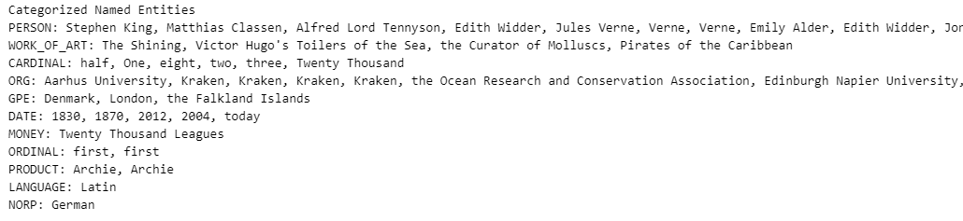
Figure 2. Categorized Named Entity from ‘Paragraf.txt’ Result

